Example 1:
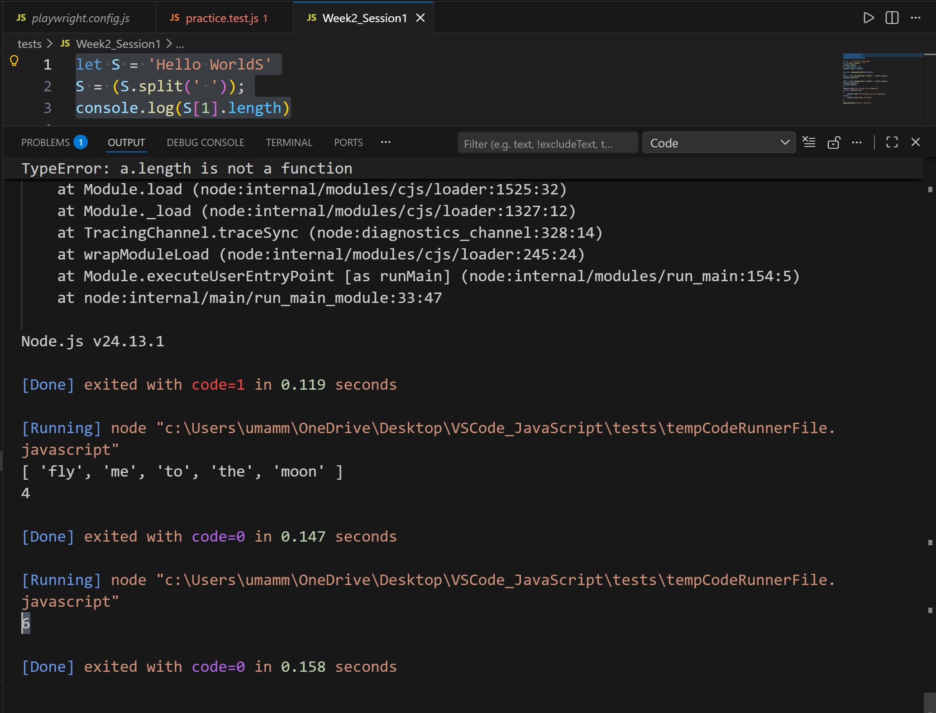
Example 2:
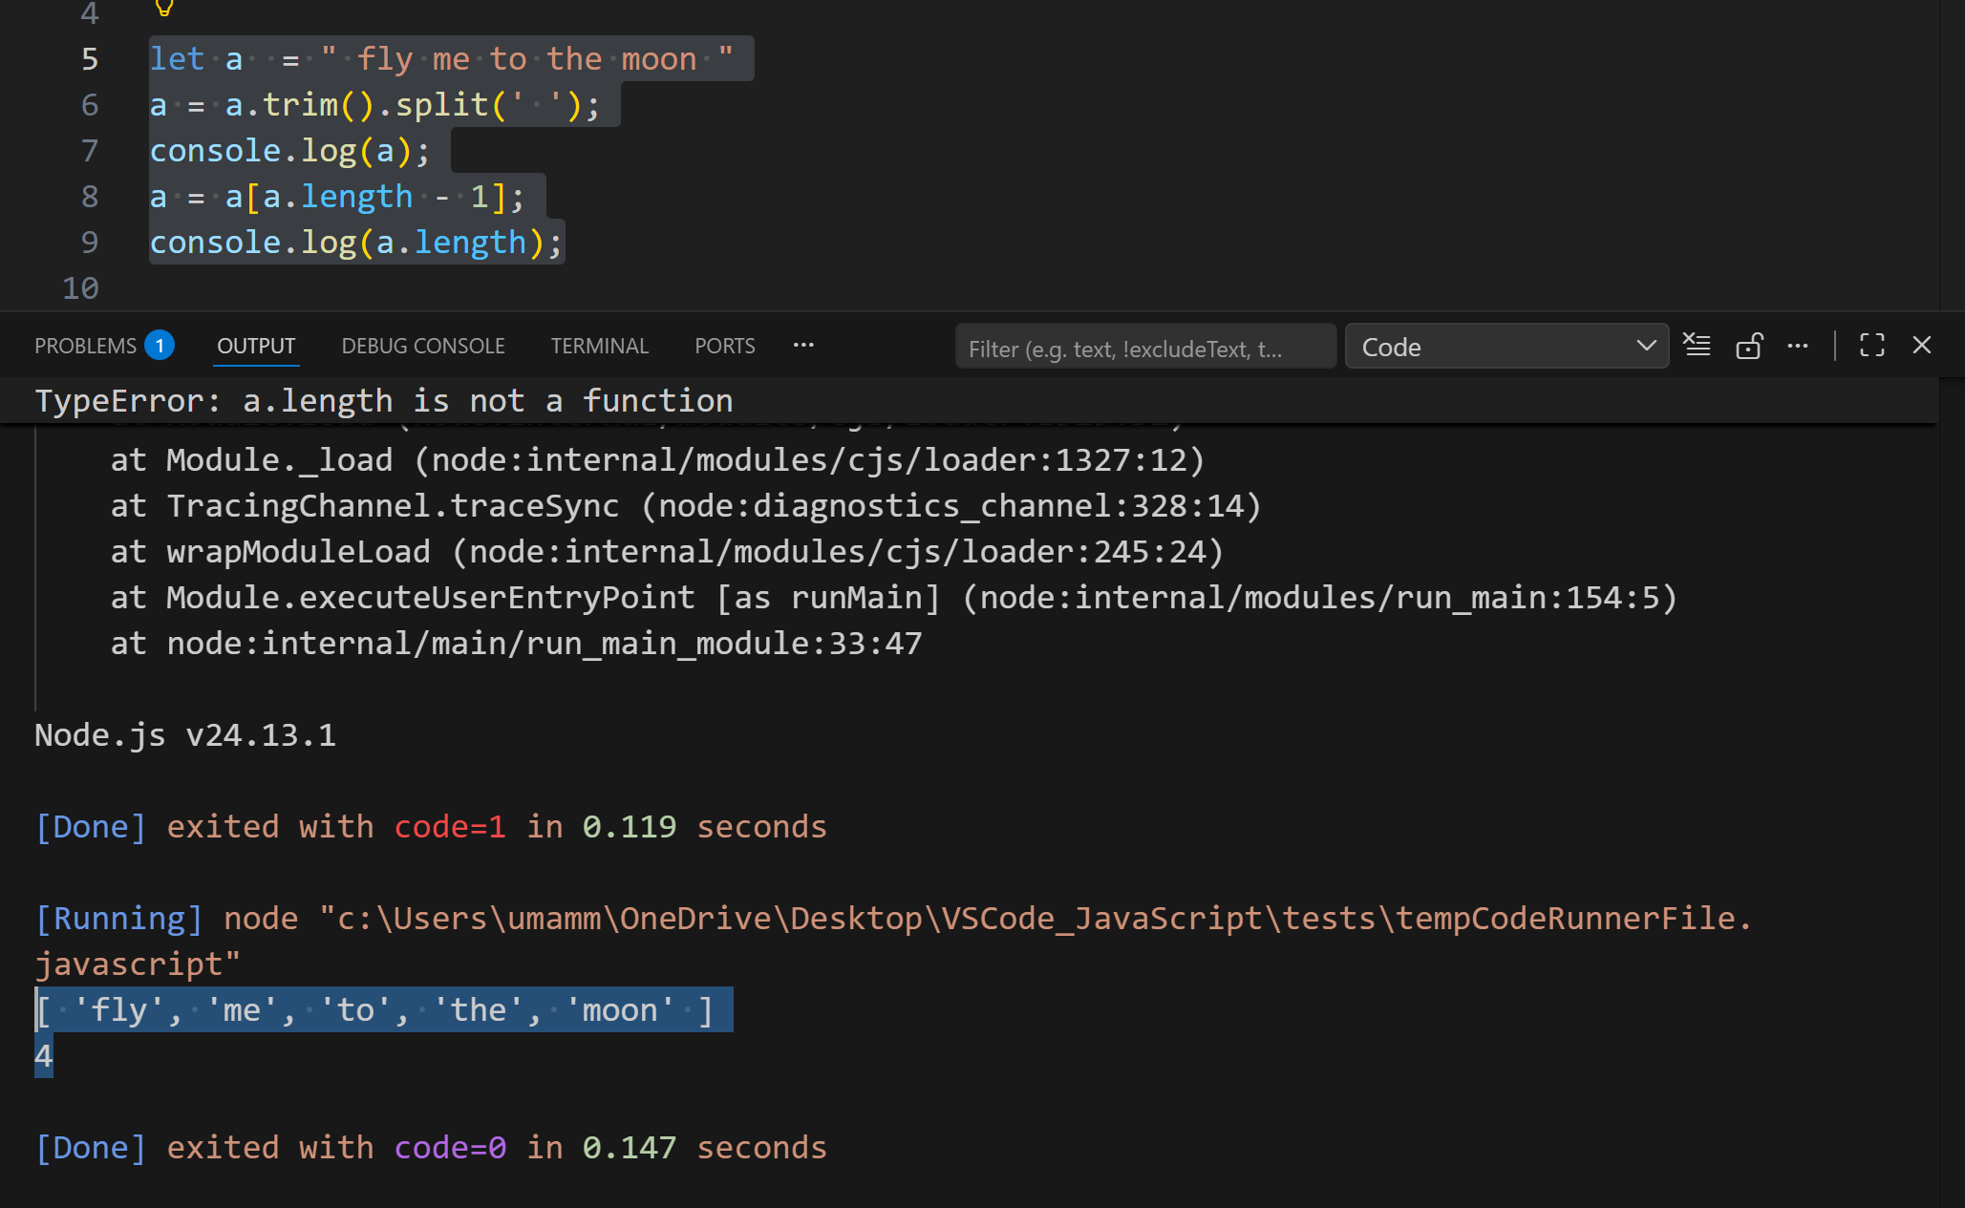
Example3:
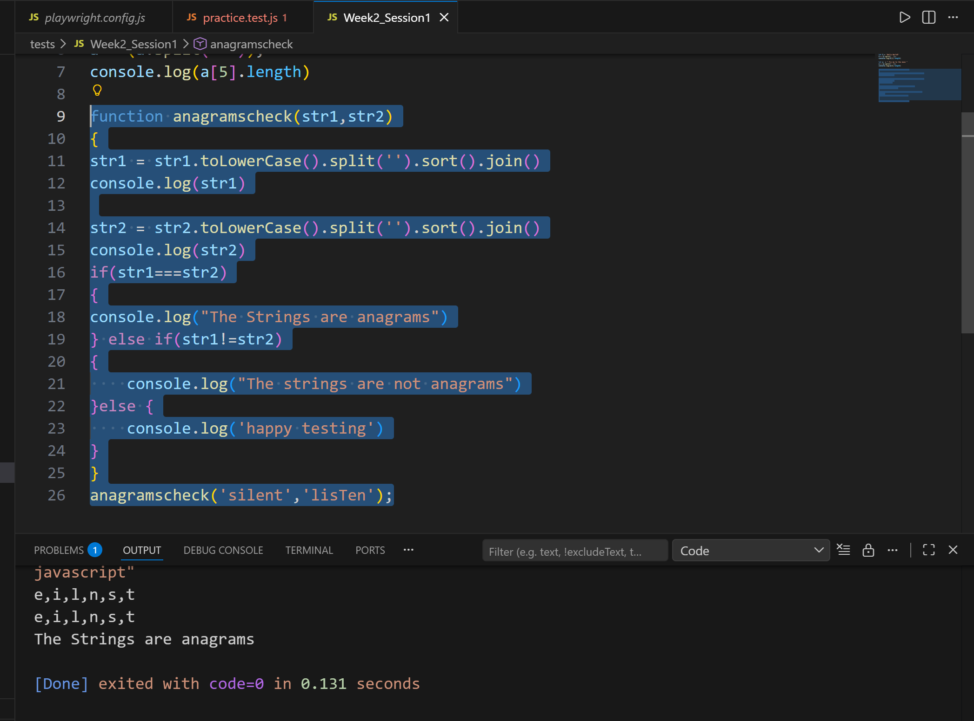
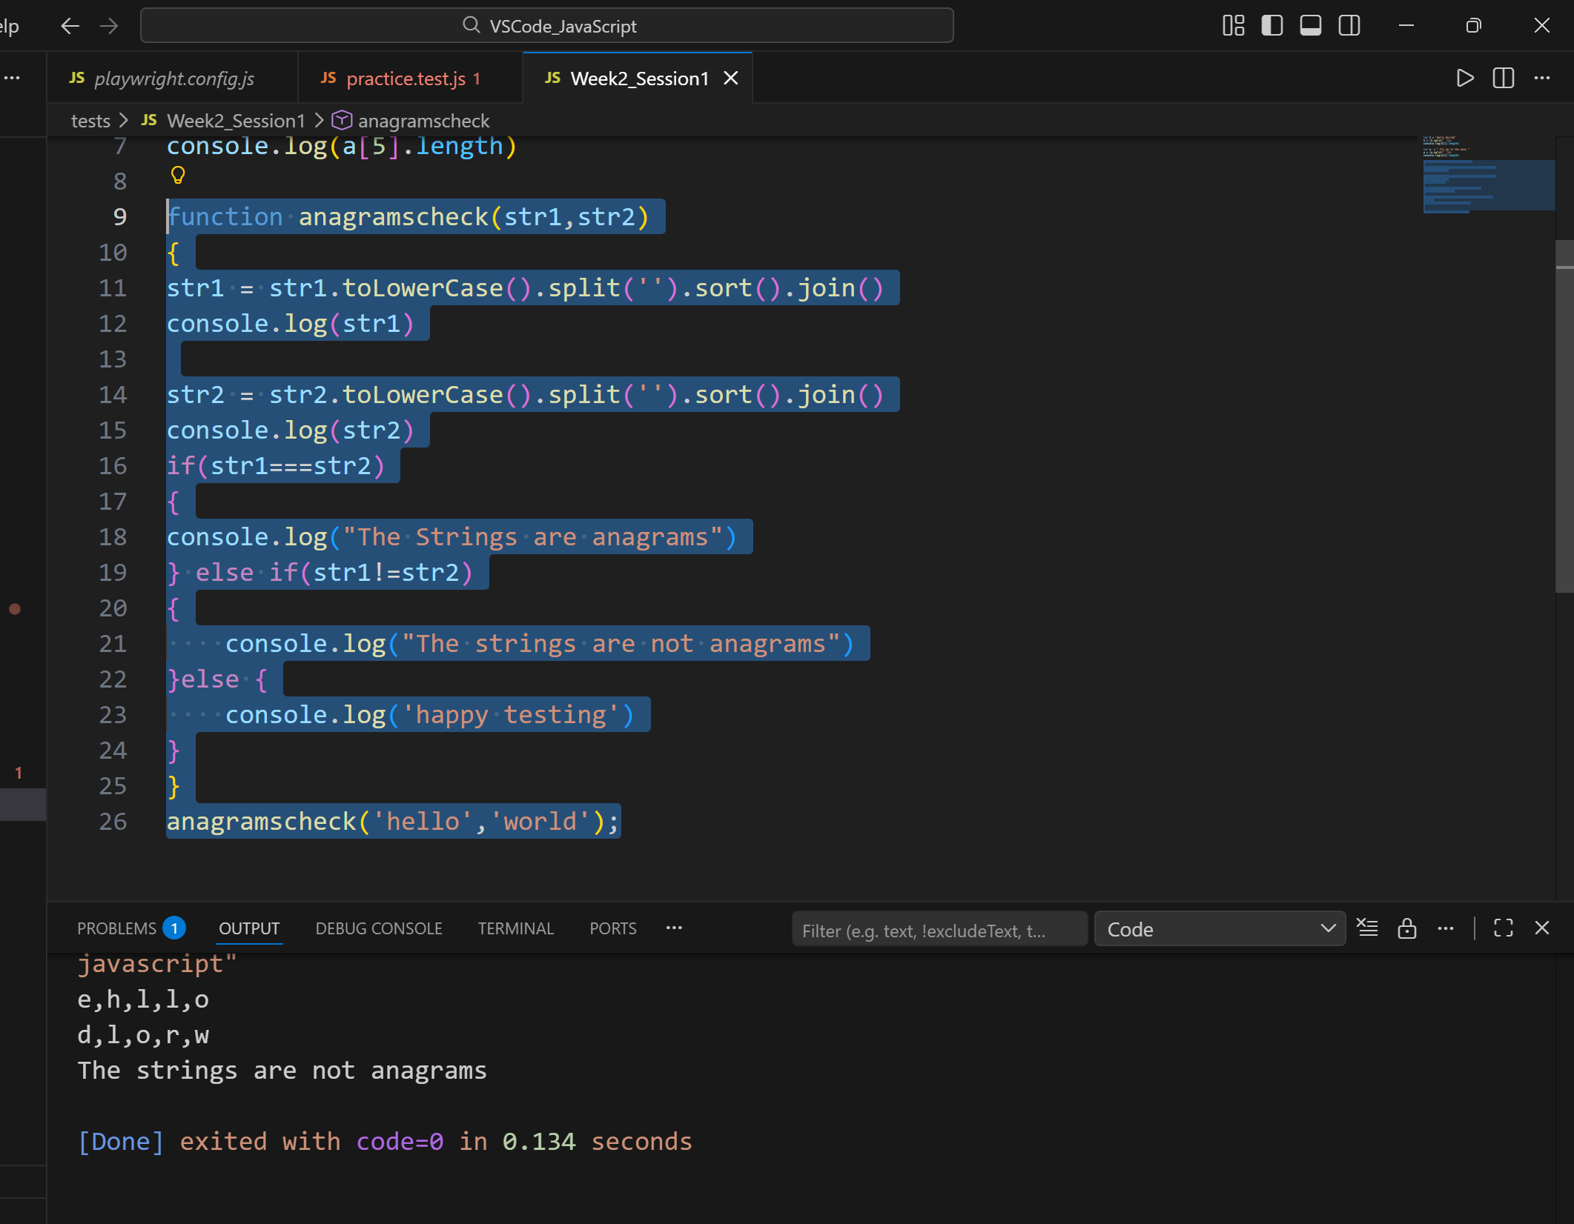

Code:
//Example1

let S = 'Hello WorldS'
S = (S.split(' '));
console.log(S[1].length)

//Example2
let a = " fly me to the moon "
a = a.trim().split(' ');
console.log(a);
a = a[a.length - 1];
console.log(a.length);

//Example3
function anagramscheck(str1,str2)
{
str1 = str1.toLowerCase().split('').sort().join()
console.log(str1)

str2 = str2.toLowerCase().split('').sort().join()
console.log(str2)
if(str1===str2)
{
console.log("The Strings are anagrams")
} else if(str1!=str2)
{
console.log("The strings are not anagrams")
}else {
console.log('happy testing')
}
}
anagramscheck('hello','world');

